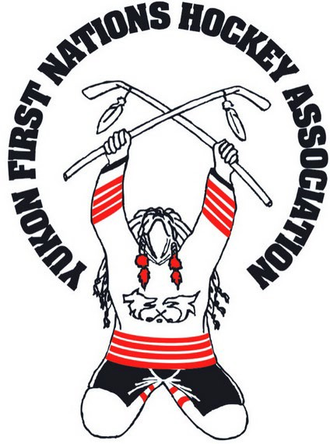
“OLD TIMERS” DIVISION ~ Entry Fee: $800
Team Entry Form Tournament Date: March 23rd to 26th, 2023

43rd Annual Kilrich Yukon Native Hockey Tournament
Yukon First Nations Hockey Association
P.O. Box 31769
Whitehorse, Yukon Y1A 6L3 Phone: (867) 456-7294
Email: yfnhahockey@gmail.com Website: www.yfnha.ca

Team Name: Coach/Manager Name:

Contact Person: Contact Number:

E-Mail: Community Representing:

Team Roster and Waiver

In consideration of being allowed to participate in any way in the Yukon First Nations Hockey Association’s athletic/sports program, related events and activities, the undersigned acknowledges and agrees that:

- The risk of injury from the activities involved in the event are significant, including the potential for permanent paralysis and death, while particular rules, equipment and personal discipline may reduce this risk of serious injury does exist;
- I KNOWINGLY AND FREELY ASSUME ALL SUCH RISKS, both known and unknown, even if arising from the negligence of the releases or others, and assume full responsibility for my participation;
- I willingly agree to comply with the stated and customary terms and conditions for participation. If I observe any unusual hazard during my presence or participation, I will remove myself from participation and bring such to the attention of the nearest official immediately;
- I, for myself and on behalf of my heir, assigns, personal representatives and next of kin, HEREBY RELEASE THE YUKON FIRST NATIONS HOCKEY ASSOCIATION, their officers, officials, agents and/or employees, other participants, sponsoring agencies, sponsors, advertisers, and if applicable, owners and lessors of the premises used to conduct the event (“Releasees”), with respect to any and all injury, disability, death, or loss or damage to person or property, whether caused by the negligence of the releasees or otherwise; and
- I, for myself and on behalf of my heirs, assigns, personal representatives and next of kin, HEREBY INDEMINFY AND HOLD HARMLESS all the above Releases from any and all liabilities to my involvement or participation in this event.

PICTURE/Video Graphing - RELEASE AUTHORIZATION
By signing the waiver for the undersigned, I do hereby consent and agree that the pictures & Videos taken of players will be used by the Yukon First Nations Hockey Association for purposes in publications or other visual processes. The Yukon First Nations Hockey Association reserves the right to have the final selection of which pictures/Videos will be used. I understand that my involvement in this activity does not guarantee that my picture(s) or Videos will be used.
Registration opens on Wednesday, February 1st, 2023 and the deadline is Wednesday, February 8th, 2023 @4pm Yukon Time.
PAYMENT MUST BE SUBMITTED WITH THE REGISTRATION!!
- Email your registration to yfnhahockey@gmail.com, and text or call 867.456-7294 with your team’s name & division.
- You will be contacted when your registration and payment is confirmed.

OT’s DIVISION ENTRY FORM – 2023: Page 1/2

TEAM NAME: 2023 - OT’s Registration Form
I read this Release of Reliability and Assumption of Risk Agreement, fully understand its terms, understand that I have given up substantial rights by signing it, and sign it freely and voluntarily without any inducement.

Indigenous Players Full Name | Status Card # OR  Attached FN Letter (MANDATORY) | Date of Birth (REQUIRED)  (YYYY/MO/DD) | Signature of Player
1.
2.
3.
4.
5.
6.
7.
8.
9.
10.
11.
12.
13.
14.
15.
Non-Indigenous Player’s Full Name |  | Date of Birth (REQUIRED) | Signature of Player
1.
2.
3.
Goalie’s Full Name | Native or Non-Native | Date of Birth | Signature of Player
1.
2.

Proof of Ancestry: all First Nation and Inuit hockey players must provide a copy of Proof of Ancestry. Proof of Ancestry includes the following:
- a Status or Treaty Card;
- a certified Nunavut Trust card, roll number or any other proof accepted by Inuit communities; or
- official letter from First Nation indicating that you are a member.
- Metis Hockey Players: All Metis hockey players must submit a Metis Player Application Form along with an official letter from a recognized Metis organization to the Yukon First Nations Hockey Association by Friday, March 17th, 2023. The Yukon First Nations Hockey Association will approve or deny the Metis Player Application form based upon the information provided. Form can be found at www.yfnha.ca

.
DECLARATION OF ANCESTRY
This form is provided for anyone that cannot provide a Status card at the time of registering as a First Nation hockey player for the Yukon First Nations Hockey Associations’ Annual Hockey Tournament.
PLEASE SUBMIT THIS INFORMATION ON YOUR FIRST NATION (REGISTRY/STATUS SERVICES) LETTERHEAD.
- THOSE WHO FAIL TO PROVIDE VALID PROOF OF ANCESTRY TO YFNHA BEFORE MARCH 22ND 2023 WILL NOT PLAY IN THE TOURNAMENT.
- Metis Cards/Letters must be submitted by March 17th, 2023. THERE WILL BE NO EXCEPTION TO THIS RULE!!!

Applicant Information

Full Name:

Date of Birth (YYYY/MO/DD) Gender:

Full Mailing Address:

Daytime Phone: Evening Phone:

Declaration of Ancestry

This part of the must be completed by the First Nation or Inuit Organization.

Full Name of First Nation or Inuit Organization:

Full Address of First Nation Or Inuit Organization:

Contact Person (Full Name): Phone Number: Fax Number: Registry Number: Region:

I, , the register/status services representative for the
(Full Name of Register/Status Services Representative)

, here by declare that
(Full Name First Nation) (Full Name of applicant)

is a member or descendant of our First Nation. I hereby declare that the information provided in this statement is true to my knowledge and will be held responsible for any conflicts arising from this declaration.

Signature of First Nation Register/Status Services Representative

