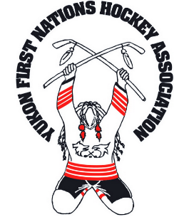
DECLARATION OF ANCESTRY

This form is provided for anyone that is not able to provide a Status card at the time of registering as a Aboriginal hockey player for the Yukon First Nations Hockey Association Annual Hockey Tournament.
PLEASE SUBMIT THIS INFORMATION ON YOUR FIRST NATION
(REGISTRY/STATUS SERVICES) LETTERHEAD.

    - Players who fail to provide valid Proof of Ancestry to YFNHA before March 17th, 2023 will not play in the tournament. Metis Hockey Player’s Application must be submitted by noon on Friday, March 17th, 2023 and be approved by the Yukon First Nations Hockey Association before a player is eligible to play. There will be no exception to this rule!!!

Applicant Information

Full Name:

Date of Birth (YYYY/MM/DD): Gender: ___________

Full Mailing Address:

Daytime Phone:

Evening Phone:

Proof of Status

This part of the form needs to be completed by the First Nation (Registry/Status Services) and will need to be return to the YFNHA Board of Directors along with the Team Registration and Fees. Any Declarations forms not accompanied with the Registration may or may not be accepted.

Full Name of First Nation (Registry Group):

Full Address of First Nation:

Contact Person (Full Name):
Phone Number:
Fax Number:
Registry Number:
Region:

I, , the register/status services representative for the
(Full Name of Register/Status Services Representative)

, here by declare that
(Full Name of First Nation) (Full Name of applicant)

is a member/descendant of our First Nation. I hereby declare that the information provided in this statement is true to my knowledge and will be held responsible for any conflicts arising from this declaration.

Signature of First Nation Register/Status Services Representative

